BRAND KIT | 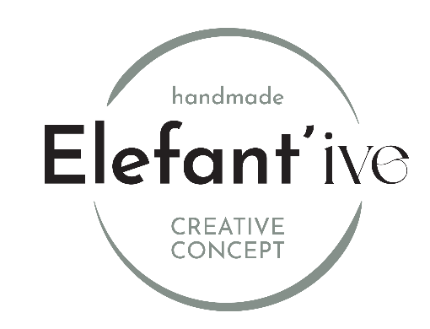

Colors
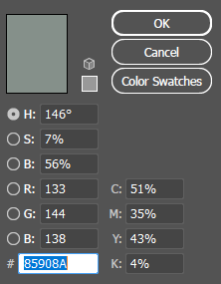 | 85908A  133  144  138  51  35  43  4
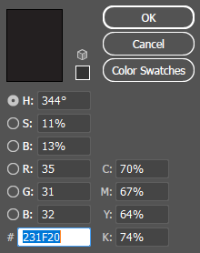 | 231F20  35  31  32  70  67  64  74
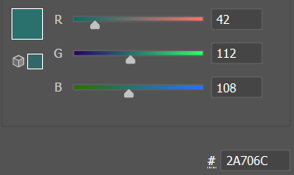 | 2A706C  42  112  108  83.17  38.42  55.26  16.88

Fonts
Elefantive | Baloo | Bold | 150 pt
handmade | Josephin sans | Regular | 60 pt
Creative concept | Josephin sans | Regular | 60 pt

